Proof of concept

1. Implement an API endpoint to retrieve a movie with all details of the movie - actors, director, genre, reviews.  
  
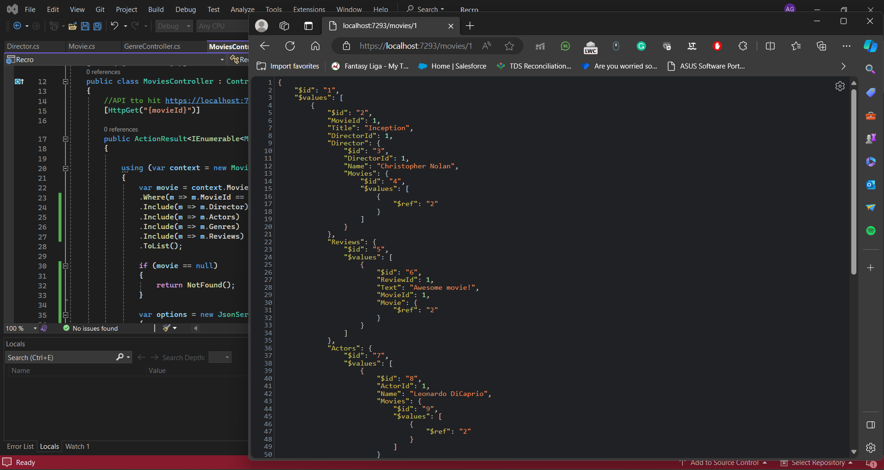

2. Implement an API endpoint to retrieve an actor with a list of all movies.

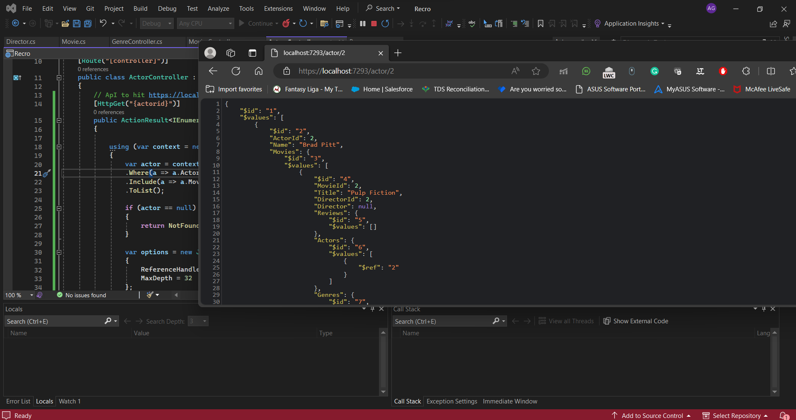

3. Implement an API endpoint to list all movies by a genre.

